

THE COPPERBELT UNIVERSITY  
SCHOOL OF INFORMATION COMMUNICATION TECHNOLOGY

Smart Bin: AI-Driven Waste Sorting  
Project Proposal

**Done By**

Name: Bulaya Mwanaute

SIN: 20150307

Programme: Computer Engineering

Supervisor: Prof. Mbale

Table of Contents

1. Background Information 3

2. Introduction 3

3. Problem Statement 4

4. Objective 4

Specific Objectives 4

5. Hypothesis and Assumptions 4

6. Scope of Study 5

7. Literature Review 5

7.1. Waste Management Challenges in Zambia 5

7.2. Importance of Sorting Waste 6

7.3. Existing Waste Sorting Methods and Their Limitations 6

7.4. Research Gap and Justification for the Smart Bin Project 6

8. Research Methodology 6

8.1. Research Approach 6

8.2. System Development Methodology 6

8.3. Materials and Tools 7

8.4. System Development Process 7

8.5. Data Collection & Analysis 8

8.6. Validation & Testing 8

8.7. Ethical Considerations 8

8.8. Summary 8

9. Ethical Issues in Computer Science, Computer Engineering, and Information Systems Research 8

10. Hardware Architecture 9

11. Project Timeline (Gantt Chart) 10

12. Financial Implications (Estimated Budget) 11

13. References 11

* 1. Background Information

Waste management is one of the most pressing environmental challenges of the modern era. As global populations grow and urbanization accelerates, the volume of waste generated continues to increase at an alarming rate. Traditional waste disposal methods, such as landfilling and incineration, contribute significantly to environmental degradation, including soil contamination, air pollution, and greenhouse gas emissions.

Recycling is a widely recognized solution to mitigate these impacts, yet its effectiveness is often hindered by improper waste segregation at the source. Many people dispose of waste incorrectly due to a lack of awareness, leading to recyclable materials ending up in landfills. Manual waste sorting is labor-intensive, inefficient, and often hazardous, exposing workers to health risks.

The advent of **artificial intelligence (AI), computer vision, and Internet of Things (IoT) technologies** presents an opportunity to revolutionize waste management. Smart waste sorting systems powered by AI can significantly enhance the efficiency and accuracy of waste classification, ensuring that recyclable materials are properly identified and redirected to the appropriate recycling channels. This project proposes the development of an **AI-driven smart bin** capable of automatically sorting waste based on material type, thus promoting sustainable waste management practices and reducing landfill waste.

* 1. Introduction

In recent years, waste generation has increased due to rapid industrialization, urbanization, and changes in consumer behavior. The improper disposal of waste has led to severe environmental problems, including pollution, depletion of natural resources, and increased carbon emissions. While many countries have implemented recycling programs, these efforts are often undermined by **inefficient sorting** at the disposal stage. The reliance on **human labor** for waste segregation is not only costly and inefficient but also poses health risks to workers handling hazardous materials.

With advancements in **machine learning, image recognition, and IoT-based automation**, AI-driven solutions can address these challenges by introducing **smart waste sorting systems**. These systems leverage **computer vision and AI models** to identify and classify waste into categories such as plastics, metals, paper, and organic waste. By automating waste sorting, this project aims to reduce human effort, improve recycling rates, and contribute to a more sustainable future.

The **Smart Bin: AI-Driven Waste Sorting** project proposes the development of an intelligent waste management system that uses **computer vision and sensor-based detection** to automatically classify and sort waste into designated compartments. The system will be designed to be user-friendly, cost-effective, and adaptable for both household and industrial use.

This document is structured as follows:

* **Background Information:** Discusses the importance of waste management and the need for automation in sorting.
* **Problem Statement:** Identifies key challenges in current waste sorting methods and the motivation behind this project.
* **Objectives:** Outlines the primary and specific objectives of the project.
* **Scope of Study:** Defines the limitations and coverage of the research.
* **Literature Review:** Examines existing solutions and research related to smart waste management.
* **Research Methodology:** Describes the techniques, tools, and approaches used in developing and testing the system.
* **Significance of the Study:** Explores the potential impact of this project on environmental sustainability and waste management efficiency.
* **Expected Contribution and Implications:** Discusses how this project can contribute to technological and social advancements.
* **Ethical Considerations:** Reviews the ethical concerns surrounding AI-based waste sorting.
* **Project Timeline and Budget:** Provides a breakdown of the project phases and expected financial costs.
  1. Problem Statement

Waste mismanagement remains a **global environmental and economic issue**, contributing to excessive landfill waste and pollution. A key challenge in recycling is the **incorrect sorting of materials**, which contaminates recyclables and reduces their efficiency. Current waste management solutions **lack automation and rely on human intervention**, making them prone to errors and inefficiencies.

To address this issue, a **Smart Bin with AI-driven waste classification** will be developed to **automatically identify and separate waste materials**. This will **improve recycling efficiency, reduce human sorting efforts, and encourage proper waste disposal behaviors**.

* 1. Objective

To design and develop a **Smart Bin that automatically identifies, classifies, and sorts waste** using **computer vision and IoT technology**, enhancing **waste recycling efficiency and reducing landfill waste**.

****Specific Objectives****

1. **Develop an AI-based waste classification system** capable of identifying **plastic, metal, and organic waste**.
2. **Implement a motorized sorting mechanism** that directs waste into the appropriate compartment.
3. **Develop an IoT-based system** for real-time monitoring of waste levels and collection schedules.
4. **Test and evaluate** the system’s sorting accuracy, efficiency, and effectiveness in a real-world setting.
   1. Hypothesis and Assumptions

* The **AI model** can reliably classify and sort waste materials with **high accuracy**.
* Users will **comply with using the system correctly**, reducing contamination in recyclable materials.
* The **automated sorting mechanism** will be **efficient and reliable**, reducing manual intervention in waste management.
* The system’s **IoT functionality** will improve waste collection efficiency and **minimize overflow issues**.
  1. Scope of Study

This study focuses on the **design, development, and evaluation** of an **AI-driven smart bin** capable of automatically sorting waste into different categories based on material composition. The system will utilize **computer vision, machine learning, and sensor-based detection** to classify and separate waste into recyclable and non-recyclable compartments. The primary goal is to enhance waste management efficiency, promote recycling, and reduce human intervention in waste sorting.

The scope of the study includes the following key areas:

1. **Technical Feasibility** – Developing and testing a prototype smart bin equipped with AI-powered waste classification, image recognition, and automated sorting mechanisms.
2. **User Adoption & Behavior Analysis** – Investigating how users interact with the smart bin and identifying factors influencing their willingness to use AI-driven waste sorting solutions.
3. **System Integration & Scalability** – Exploring how the smart bin could be integrated into **municipal waste management systems, recycling plants, and commercial facilities** to enhance large-scale waste sorting.
4. **Material Recognition Limitations** – Identifying potential challenges in waste identification, such as **mixed-material waste, contaminated recyclables, and AI misclassification**, and evaluating strategies to improve sorting accuracy.
5. **Power Consumption & Sustainability** – Assessing the energy requirements of the system and exploring sustainable power sources such as **solar panels or low-energy microcontrollers**.
6. **Data Privacy & Ethical Considerations** – Evaluating the ethical implications of using AI in waste management, including **data privacy concerns** if the system collects and processes user-related waste data.
7. **Economic Feasibility** – Analyzing the cost-effectiveness of the smart bin prototype and its potential for large-scale production, including **manufacturing costs, maintenance, and long-term benefits**.

The study will primarily focus on **small-scale and controlled environments**, such as **universities, offices, or residential communities**, to test the effectiveness of the prototype. However, the findings will also explore its applicability in **industrial and municipal waste management**.

* 1. Literature Review

1. Waste Management Challenges in Zambia

Zambia like many developing countries has not been spared from a number of environmental challenges one of which is, inappropriate management of waste. It is estimated that only about 7 percent of urban and rural populations have access to refuse collection and the most common method of disposal is pitting and uncontrolled dumping.  Illegal open air burning of waste is one of the most common practices for reducing waste volume. Waste is generally not segregated according to waste streams, but disposed of together through a combination of informal, public and private channels. The management of solid waste has over the years been a challenging issue in Zambia and is potentially contributing to public health and environmental implications. According to the Living Conditions Monitoring Survey of 2013/14, only 7% of households (15% urban and 2% rural) had their waste collected. (Nkwazi Magazine, 2019).

1. Importance of Sorting Waste

By separating different materials, most of them can also be recycled into new products. We save energy and natural resources by using materials multiple times. Waste sorting is part of the EU’s plan to manage our waste so that the environment and people are not harmed. Sorting our waste also reduces the amount of waste at risk of going to landfill. (“*Facts about waste management*”, 2023)

1. ****Existing Waste Sorting Methods and Their Limitations****

Current waste management systems use several approaches for sorting and recycling:

* **Eddy current separator uses a powerful magnetic field to separate non-ferrous metals from waste after all ferrous metals have been removed previously. Eddy current separators are not designed to sort ferrous metals which become hot inside the eddy current field. This can lead to damage of eddy current separator unit belt. (*Aleena et al*, 2016)**
* **Manual Sorting:** Labor-intensive and inefficient. High risk of exposure to hazardous waste.
* **Automated Sorting Facilities:** Uses optical sensors, magnets, and air classifiers, but these are costly and require large infrastructure investments.

**While some smart waste management solutions exist, many still face limitations in terms of accuracy, efficiency, and adoption at smaller scales, such as household or small business levels.**

1. ****Research Gap and Justification for the Smart Bin Project****

While **large-scale waste sorting facilities** exist, there is a **lack of small-scale, AI-driven sorting solutions** for homes, offices, and public spaces. Many current systems:

* + Are **too expensive** for individual consumers.
  + Require **external infrastructure**, making them unsuitable for standalone use.
  + Lack **adaptive learning** to improve sorting efficiency over time.
  1. Architectural Design

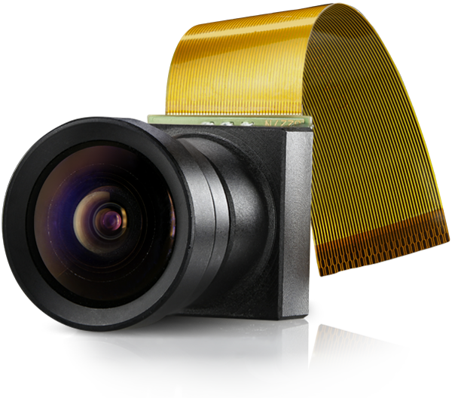

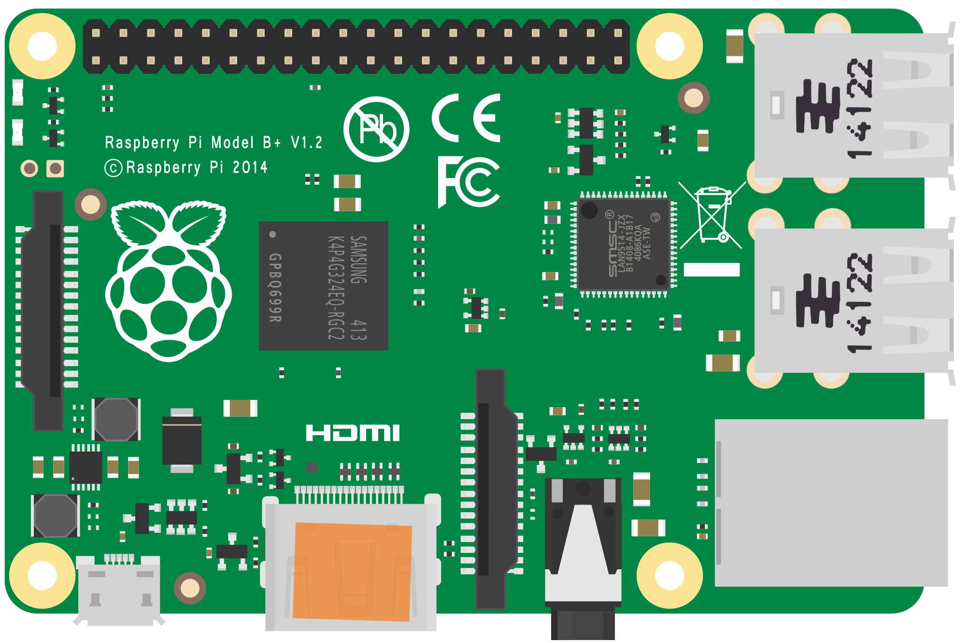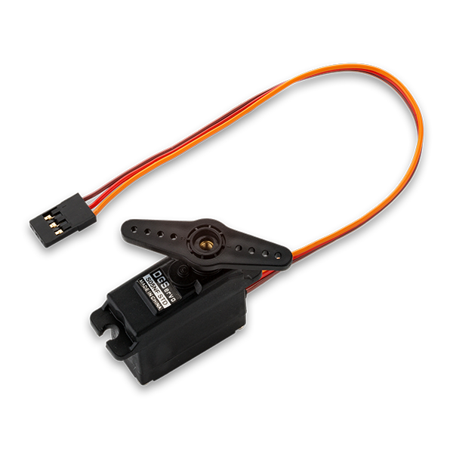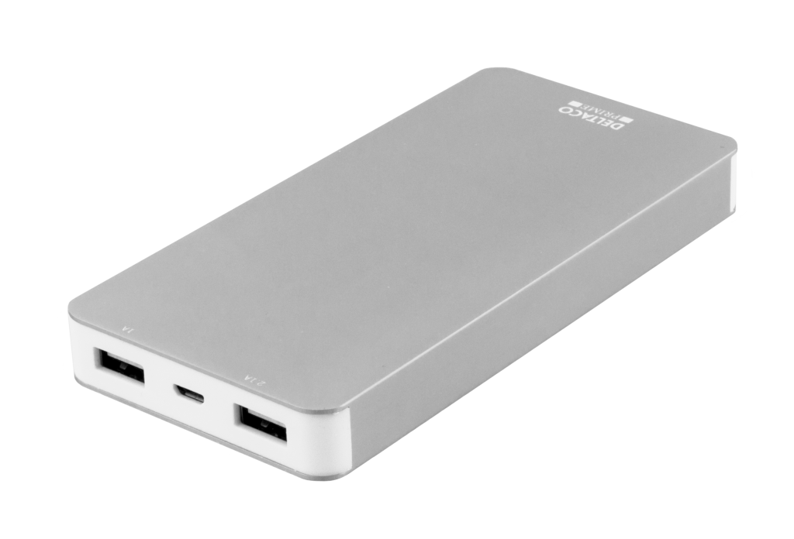

**Servo motor 1:**

For controlling rotating compartment storage

**Servo motor 2:**

For controlling bin closing and object dropping mechanism

**Servo motor 3:**

For controlling coin dispenser for reward-based system

Actuators

**Camera module:**

For capturing and detecting objects

**Ultrasonic sensor:**

For detecting when the bin is full

**Microcontroller**

For controlling all connected components, and responsible for classifying objects

**Power bank:**

Provides power for the entire system

* 1. Research Methodology

****9**.**1. Research Approach****

This study employs a **design and implementation-based approach**, integrating both **hardware and software development** to build an AI-driven smart bin for waste sorting. The research follows a **combination of experimental research** (to test the effectiveness of the smart bin) and **descriptive research** (to analyze user interaction and efficiency improvements in waste management).

****9.2. System Development Methodology****

The **Agile methodology** will be adopted for the development of the smart bin system. Agile is chosen due to its iterative nature, which allows for continuous feedback, testing, and improvements throughout the development cycle. The project will follow these stages:

1. **Requirement Gathering & Analysis** – Identifying the specific needs for waste sorting automation and defining the system functionalities.
2. **Design & Prototyping** – Creating 3D models and electrical circuit schematics to visualize the system.
3. **Development & Implementation** – Iterative coding, AI model training, and hardware integration.
4. **Testing & Evaluation** – Conducting functional and accuracy tests to validate waste classification and user interactions.
5. **Deployment & Feedback** – Deploying a prototype and gathering insights for improvements.

****9.3. Materials and Tools****

The project will require both **hardware** (for the physical smart bin) and **software** (for AI-based waste classification).

#### **Hardware Components:**

* **Microcontroller/Embedded System:** Raspberry Pi or Arduino for processing inputs.
* **Sensors:** Image sensors or cameras to capture waste images.
* **Actuators:** Servo motors for sorting mechanism.
* **Power Supply:** Rechargeable battery or direct power source.
* **Waste Containers:** Separate compartments for different waste categories.

#### **Software Tools:**

* **AI/ML Development:** TensorFlow/PyTorch for training the waste classification model.
* **Programming Languages:** Python (for AI), C++/MicroPython (for microcontroller programming).
* **Database:** Firebase/MySQL for logging collected data.
* **Simulation & 3D Modeling:** Blender/Fusion 360 for designing the bin prototype.

****9.4. System Development Process****

The development process includes:

1. **AI Model Training:**
   * Collect and preprocess a dataset of images containing different types of waste (plastic, metal, organic, etc.).
   * Train a deep learning model (CNN-based) to classify waste items.
   * Optimize the model for real-time classification on an embedded system.
2. **Hardware Integration:**
   * Connect sensors and actuators to a microcontroller (e.g., Raspberry Pi).
   * Implement an **object detection algorithm** to trigger waste sorting mechanisms.
   * Develop a mechanism that directs waste to the correct bin.
3. **Software Implementation:**
   * Develop the embedded software that communicates with the AI model.
   * Implement a user interface for monitoring waste classification statistics.
   * Integrate cloud storage for logging waste data.

****9.5. Data Collection & Analysis****

Data will be collected during system testing, including:

* **Classification Accuracy:** How well the AI model identifies waste types.
* **Sorting Efficiency:** Time taken for the bin to sort an item.
* **User Interaction Feedback:** Ease of use, acceptance, and effectiveness.

Data analysis methods will include:

* **Accuracy Metrics:** Precision, recall, and F1-score for AI classification.
* **Performance Evaluation:** Comparing sorting efficiency before and after system implementation.
* **Usability Testing:** Gathering user feedback to refine the system.

****9.6. Validation & Testing****

Testing will be conducted in multiple phases:

1. **Unit Testing:** Individual hardware and software components will be tested separately.
2. **System Integration Testing:** Ensuring all components function together seamlessly.
3. **User Acceptance Testing (UAT):** Real-world testing with users to evaluate efficiency and effectiveness.

****9.7. Ethical Considerations****

* **Data Privacy:** Images used for AI training will be collected responsibly without violating ethical data usage guidelines.
* **Environmental Impact:** The system is designed to **promote sustainability** by improving waste management.
* **User Safety:** Proper safety measures will be implemented in the hardware to prevent mechanical hazards.

****9.8. Summary****

This methodology outlines the structured approach to designing and developing an AI-driven smart bin that automates waste sorting. The use of Agile methodology ensures continuous improvements, while AI and embedded systems facilitate real-time waste classification and disposal. Data collection and testing will validate the accuracy, performance, and usability of the system.

* 1. ****Ethical Issues in Computer Science, Computer Engineering, and Information Systems Research****
* **Privacy Concerns:** IoT-enabled waste bins may collect user data; **privacy policies must be implemented**.
* **Bias in AI Models:** The classification algorithm must be **trained on diverse waste datasets** to avoid bias.
* **Environmental Responsibility:** The system itself should be **energy-efficient** and use **recyclable components** where possible.
* **Accessibility:** The design should be **user-friendly** for people with disabilities.
  1. Project Timeline (Gantt Chart)

| ****Task**** | | ****Duration**** | **March** | | April | | May | | June | July | August | |
| --- | --- | --- | --- | --- | --- | --- | --- | --- | --- | --- | --- | --- |
|  | |  | |  | |  |  |  | |
| **1. Project Planning and research** | Finalising project scope | 2 weeks |  |  |  | |  | |  |  |  | |
| Conducting literature review | 6 weeks |  | |  |  |  | |  |  |  | |
| Requirements analysis | 8 weeks |  | |  | |  | |  |  |  | |
| 2. System Design and Modelling | Designing system architecture | 4 weeks |  | |  |  |  | |  |  |  | |
| Creating hardware schematic | 8 weeks |  | |  | |  | |  |  |  | |
| Developing 3D model | 4 weeks |  | |  |  |  | |  |  |  | |
| 3. AI Model Development and Training | Colecting waste image dataset |  |  | |  |  |  | |  |  |  | |
| Training waste classification AI |  |  | |  |  |  |  |  |  |  | |
| Optimising for embedded system |  |  | |  | |  |  |  |  |  | |
| 4. Hardware development and integration | Assembling bin hardware |  |  | |  | |  | |  |  |  | |
| Integrating AI with microcontroller |  |  | |  | |  | |  |  |  | |
| Programming sorting mechanism |  |  | |  | |  | |  |  |  | |
| 5. Testing and optimisation | Testing model accuracy |  |  | |  | |  | |  |  |  | |
| Evaluating hardware efficiency |  |  | |  | |  | |  |  |  | |
| Refining model performance |  |  | |  | |  | |  |  |  |  |
| 6. Documentation and final presentation | Completing project report |  |  | |  | |  | |  |  |  | |
| Preparing final presentation |  |  | |  | |  | |  |  |  | |
| Submission and project defense |  |  | |  | |  | |  |  |  | |

* 1. Financial Implications (Estimated Budget)

| ****Component**** | ****Estimated Cost (ZMW)**** |
| --- | --- |
| Microcontroller (e.g., Raspberry Pi/ESP32) | K450 |
| Camera Module (for AI vision) | K400 |
| Breadboard | K200 |
| Servo motor x 2 | K500 |
| Power Supply & Battery | K350 |
| Hot glue gun | K130 |
| Glue sticks | K30 |
| Ultrasonic sensor | K500 |
| Miscellaneous (Wiring, PCB, Enclosure) | K350 |
| **Total Estimated Cost** | **K2910** |

* 1. References
* *Nkwazi Magazine*. (2019, May 7). Waste management, a challenge for Zambia.
* *sopor.nu*. (2023, August 17). Facts about waste management.
* Aleena V.J.*, Kavya Balakrishnan, Rosmi T.B., Swathy Krishna K.J., Sreejith S & T.D.  
  Subha. (2017, June 21).
* Recycleeye. (2019). AI and Waste Recognition – Why It Works So Well.  
  https://recycleye.com/ai-and-waste-recognition-why-it-works-so-well/